Documentation for the new Widgets to UAVObj relations Framework.
Objectives:
- Handle widgets dirty state flagging.
- Handle widgets values changes according to UAV objects values changes and vice versa.
- Handle reload and default operations.
- Handle upload and saving operations.
- Handle help buttons presses.
- Handle UAV objects value limits by trying to limit user interaction and visually signaling out of limits values.
- Use information defined by UI designers on Qt Creator designer to define all of the previous points.

- Handle widgets dirty state.
All widgets added will be watched for value changes, this is to be normally used with “warning you have unsaved changes” type messages.
Widgets are added by the following functions:
- addWidget
- addUAVObjectToWidgetRelation
- addShadowWidget
The dirty status can be queried with the bool isDirty() function.
The following widget types are supported:
- QComboBox
- QSlider
- MixerCurveWidget
- QTableWidget
- QSpinBox
- QDoubleSpinBox
- QCheckBox

- Handle widgets values changes according to UAV objects values changes and vice versa.
This is one of the main features of this framework, it allows the definition of a relation between an UAVObject field and a widget. This relation can be weighted by a scale value. Multiple widgets can be used to display the data of the same UAVObject field.
Relations can be added by the following functions:
- addUAVObjectToWidgetRelation
- addShadowWidget

addShadowWidget can only be used if a previous relation was created with addUAVObjectToWidgetRelation, however it is not necessary to use it directly, you can just use addUAVObjectToWidgetRelation for all relations which in turn will call addShadowWidget if needed.

- Handle reload and default operations.
A reload operation is used to retrieve an UAV Object field value from the FC persistent memory (internal flash, external flash, SD card). A default operation retrieves the default value (defined on the object’s xml file) of an UAV Object field.
For each default or reload buttons the coder assigns a group number and for every widget passed on the relation definition he assigns a list of group numbers. If the user presses a button of operation X (default or reload) with group Y the framework will search every widget with group Y defined and perform operation X.
Buttons are added with the following functions:
- addDefaultButton(QPushButton *button, int buttonGroup)
- addReloadButton(QPushButton *button, int buttonGroup)

Widgets are added with the following functions:
- addUAVObjectToWidgetRelation(QString object, QString field, QWidget *widget, QString element, double scale, bool isLimited, QList<int> *defaultReloadGroups, quint32 instID)
- addUAVObjectToWidgetRelation(QString object, QString field, QWidget * widget, int index,double scale,bool isLimited,QList<int>* defaultReloadGroups, quint32 instID)
- addShadowWidget(QString object, QString field, QWidget *widget, int index, double scale, bool isLimited,QList<int>* defaultReloadGroups,quint32 instID)

- Handle upload and saving operations.

All uploading and saving operations of objects added to the framework management system are handled by the framework itself. The framework makes sure that the operations succeeded and signals this by manipulation the save and upload buttons icons.
To use this feature the coder needs to assign save and upload buttons (one or many) and UAV Objects. UAVObjects which are part of a uavobj to widget relation are automatically handled.
To add buttons use:
- addApplySaveButtons(QPushButton *update, QPushButton *save)
To add a standalone objects use:
- addUAVObject(QString objectName)

- Handle help buttons presses.

A common task is to use a help button to open a browser page containing help information. The framework provides a helper function to handle this. The coder only has to tell the framework which button opens which url using the function:
- addHelpButton(QPushButton *button, QString url)

- Handle UAV objects value limits by trying to limit user interaction and visually signaling out of limits values.
Limits are defined on the XML object definition file under the “limits” tag with the following format:
%XX:Y:Z, %AA:B:C,…
XX and AA – Type of limit – BE for between, BI for bigger, SM for smaller, EQ for equal, NE for not equal.
Y,Z,B,C- limit values.

Smaller and bigger values use only on value, if more than one is defined only the first will be used.
Between uses only two values, if more than two is defined only the two first ones will be used.
Equal uses n values, a value is considered inside limits if it is equal to any of the values defined.
Not equal uses n values, a value is considered outside limits if it is equal to any of the values defined.

To each field element only one limit operation can be assigned, in the example above %XX:Y:Z defines the limit operation for an objects field element of index 0 and %AA:B:C for index 1…

The framework tries to limit the possible user interaction to keep the values inside the limits on the widgets that allow this (QSlider, QDoubleSpinBox…). With this kind of widgets if the value is externally forced to a value outside the limits the framework will adapt the widgets limits to that value but will change its style sheet to signal the out of limits status. The original stylesheet and limits are used again once the value goes inside limits again.
With widgets which are “impossible” to limit the user interaction with, the framework still changes their stylesheet to signal the value going outside the limits.
The default outside of limits stylesheet is:
- “background-color: rgb(255, 0, 0);”
And can be changed using:
- setOutOfLimitsStyle(QString style)
If the coder wants to use this feature he only needs to set the “isLimited” bool to true when defining the uavobj to widget relation.

- Use information defined by UI designers on Qt Creator designer to define all of the previous points.
Every feature described until know can be used using only one line of code:
- autoLoadWidgets();
That’s because all the required information can be defined using the designer. To do this a custom property should be added. It should be named “objrelation” and of type “QStringList”
To do this follow the visual instructions bellow for each widget you want to automatically add to the framework.
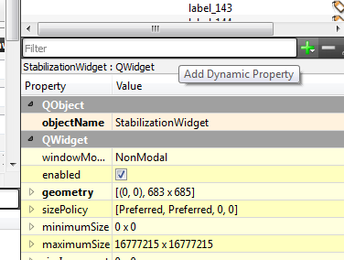press the green “plus” sign.
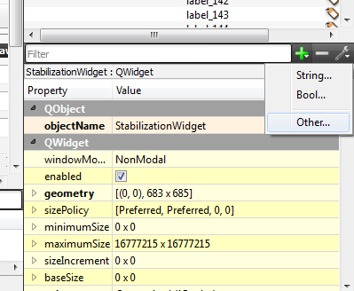choose other
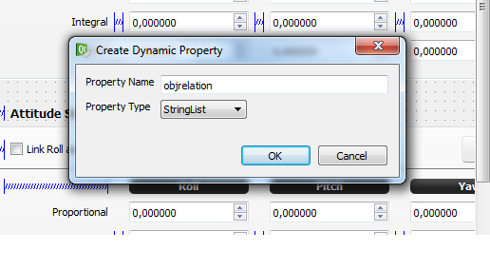Name the property “objrelation” and set it to type “StringList”
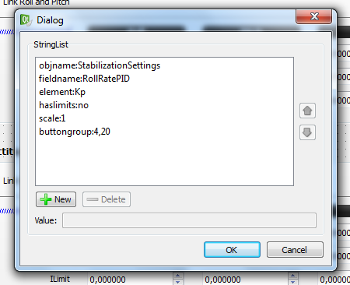Use the required property name followed by a “:” and a value to define the widget.
Available properties are:
Property | Required | Default value | Possible values
objname | For uavobj to widget relation definition | - | Any valid object name
fieldname | For uavobj to widget relation definition |  | Any valid field name
element | No | Element of index 0 | Any valid element name
scale | no | 1 | Any double value
haslimits | no | no | “yes” or “no”
button | For button definition |  | “save”, “apply”,”reload”, “default”, “help”
url | For help button definition |  | Any valid URL

A complete example on how to use this feature can be found on the stabilization configuration widget code.
How to use this framework?
Include the file uavobjectwidgetutils.pri on your .pro file.
Inherit from the “ConfigTaskWidget” class.

